**Name : Saswata Kumar Nayak Mail id : [22053848@kiit.ac.in](mailto:22052504@kiit.ac.in)**

**Superset id : 6363187 University Roll : 22053848**

**WEEK - 08 : HandsOn Solutions**

**#1. Git - 01**

KIIT@BT-22053848 MINGW64 ~

$ git version

git version 2.46.2.windows.1

KIIT@BT-22053848 MINGW64 ~

$ git config --global --list

user.gmail=saswatnyk123@gmail.com

user.name=Saswata Kumar Nayak

user.email=saswatnyk123@gmail.com

KIIT@BT-22053848 MINGW64 ~

$ notepad++

KIIT@BT-22053848 MINGW64 ~

$ notepad++.exe bash -profile

KIIT@BT-22053848 MINGW64 ~

$ git config --global core.editor "notepad++.exe -multiInst -nosession"

KIIT@BT-22053848 MINGW64 ~

$ git config --global -e

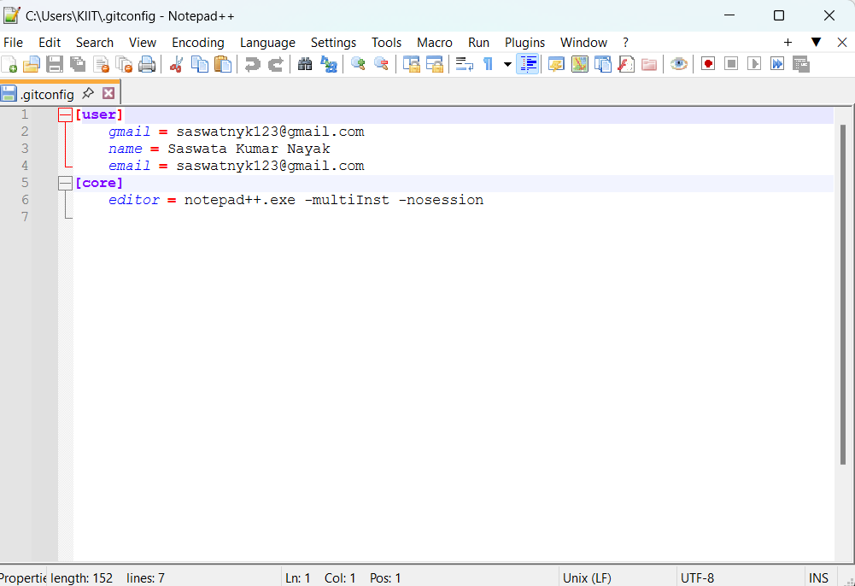

KIIT@BT-22053848 MINGW64 ~

$ git init GitDemo

Initialized empty Git repository in C:/Users/KIIT/GitDemo/.git/

KIIT@BT-22053848 MINGW64 ~

$ ls -al

total 27429

drwxr-xr-x 1 KIIT 197121 0 Aug 9 12:36 **.**/

drwxr-xr-x 1 KIIT 197121 0 Oct 25 2022 **..**/

drwxr-xr-x 1 KIIT 197121 0 Jul 10 2023 **.MobiVBox**/

-rw-r--r-- 1 KIIT 197121 175 May 25 14:31 .angular-config.json

-rw-r--r-- 1 KIIT 197121 174 Aug 9 12:21 .bash_history

drwxr-xr-x 1 KIIT 197121 0 Dec 27 2023 **.cache**/

drwxr-xr-x 1 KIIT 197121 0 Feb 26 2023 **.dbus-keyrings**/

drwxr-xr-x 1 KIIT 197121 0 Jun 19 19:53 **.dotnet**/

drwxr-xr-x 1 KIIT 197121 0 May 6 14:51 **.eclipse**/

-rw-r--r-- 1 KIIT 197121 152 Aug 9 12:34 .gitconfig

drwxr-xr-x 1 KIIT 197121 0 May 24 01:32 **.gradle**/

-rw-r--r-- 1 KIIT 197121 20 Aug 9 12:26 .lesshst

drwxr-xr-x 1 KIIT 197121 0 May 25 13:17 **.m2**/

drwxr-xr-x 1 KIIT 197121 0 Feb 5 2025 **.matplotlib**/

drwxr-xr-x 1 KIIT 197121 0 Sep 8 2022 **.ms-ad**/

drwxr-xr-x 1 KIIT 197121 0 Jul 24 2022 **.nbi**/

-rw-r--r-- 1 KIIT 197121 1154 Apr 29 16:56 .node_repl_history

drwxr-xr-x 1 KIIT 197121 0 Jul 13 23:56 **.nuget**/

-rw-r--r-- 1 KIIT 197121 174 Nov 2 2024 .packettracer

drwxr-xr-x 1 KIIT 197121 0 Dec 27 2023 **.redhat**/

drwxr-xr-x 1 KIIT 197121 0 May 6 15:08 **.sts4**/

drwxr-xr-x 1 KIIT 197121 0 Jun 19 20:03 **.templateengine**/

drwxr-xr-x 1 KIIT 197121 0 Jul 29 20:42 **.th-client**/

drwxr-xr-x 1 KIIT 197121 0 Jul 6 2023 **.vscode**/

drwxr-xr-x 1 KIIT 197121 0 Jan 18 2025 **.vscode-print-resource-cache**/

drwxr-xr-x 1 KIIT 197121 0 Oct 25 2022 **AppData**/

lrwxrwxrwx 1 KIIT 197121 29 Oct 25 2022 **'Application Data'** -> **/c/Users/KIIT/AppData/Roaming**/

drwxr-xr-x 1 KIIT 197121 0 Feb 15 2023 **'C Tutorials'**/

drwxr-xr-x 1 KIIT 197121 0 Nov 1 2024 **'Cisco Packet Tracer 7.3.0'**/

drwxr-xr-x 1 KIIT 197121 0 Oct 25 2022 **Contacts**/

lrwxrwxrwx 1 KIIT 197121 57 Oct 25 2022 **Cookies** -> **/c/Users/KIIT/AppData/Local/Microsoft/Windows/INetCookies**/

drwxr-xr-x 1 KIIT 197121 0 Aug 7 23:47 **Desktop**/

drwxr-xr-x 1 KIIT 197121 0 Jun 19 20:03 **Documents**/

drwxr-xr-x 1 KIIT 197121 0 Aug 9 12:24 **Downloads**/

drwxr-xr-x 1 KIIT 197121 0 Oct 25 2022 **Favorites**/

drwxr-xr-x 1 KIIT 197121 0 Aug 9 12:36 **GitDemo**/

drwxr-xr-x 1 KIIT 197121 0 Apr 30 2024 **HTML**/

drwxr-xr-x 1 KIIT 197121 0 Feb 2 2024 **IdeaProjects**/

drwxr-xr-x 1 KIIT 197121 0 Aug 8 22:44 **IntelGraphicsProfiles**/

drwxr-xr-x 1 KIIT 197121 0 Oct 25 2022 **Links**/

lrwxrwxrwx 1 KIIT 197121 27 Oct 25 2022 **'Local Settings'** -> **/c/Users/KIIT/AppData/Local**/

drwxr-xr-x 1 KIIT 197121 0 Oct 25 2022 **Music**/

lrwxrwxrwx 1 KIIT 197121 23 Oct 25 2022 **'My Documents'** -> **/c/Users/KIIT/Documents**/

-rw-r--r-- 1 KIIT 197121 18087936 Aug 8 22:44 NTUSER.DAT

-rw-r--r-- 1 KIIT 197121 65536 Jul 9 02:11 NTUSER.DAT{5f4f9ecc-5475-11ed-9f0c-00155d89299e}.TM.blf

-rw-r--r-- 1 KIIT 197121 524288 Jul 9 02:11 NTUSER.DAT{5f4f9ecc-5475-11ed-9f0c-00155d89299e}.TMContainer00000000000000000001.regtrans-ms

-rw-r--r-- 1 KIIT 197121 524288 Apr 4 00:07 NTUSER.DAT{5f4f9ecc-5475-11ed-9f0c-00155d89299e}.TMContainer00000000000000000002.regtrans-ms

lrwxrwxrwx 1 KIIT 197121 65 Oct 25 2022 **NetHood** -> **'/c/Users/KIIT/AppData/Roaming/Microsoft/Windows/Network Shortcuts'**/

drwxr-xr-x 1 KIIT 197121 0 Oct 15 2022 **'New folder (2)'**/

drwxr-xr-x 1 KIIT 197121 0 Feb 17 23:16 **OneDrive**/

drwxr-xr-x 1 KIIT 197121 0 Sep 8 2022 **Oracle**/

drwxr-xr-x 1 KIIT 197121 0 May 10 03:32 **Pictures**/

lrwxrwxrwx 1 KIIT 197121 65 Oct 25 2022 **PrintHood** -> **'/c/Users/KIIT/AppData/Roaming/Microsoft/Windows/Printer Shortcuts'**/

lrwxrwxrwx 1 KIIT 197121 54 Oct 25 2022 **Recent** -> **/c/Users/KIIT/AppData/Roaming/Microsoft/Windows/Recent**/

drwxr-xr-x 1 KIIT 197121 0 Oct 25 2022 **'Saved Games'**/

drwxr-xr-x 1 KIIT 197121 0 Oct 25 2022 **Searches**/

lrwxrwxrwx 1 KIIT 197121 54 Oct 25 2022 **SendTo** -> **/c/Users/KIIT/AppData/Roaming/Microsoft/Windows/SendTo**/

lrwxrwxrwx 1 KIIT 197121 58 Oct 25 2022 **'Start Menu'** -> **'/c/Users/KIIT/AppData/Roaming/Microsoft/Windows/Start Menu'**/

-rw-r--r-- 1 KIIT 197121 1059 Jan 19 2024 Student1.class

-rw-r--r-- 1 KIIT 197121 386 Jan 19 2024 Student1.java

-rw-r--r-- 1 KIIT 197121 0 Jan 19 2024 Studentgrade.java

lrwxrwxrwx 1 KIIT 197121 57 Oct 25 2022 **Templates** -> **/c/Users/KIIT/AppData/Roaming/Microsoft/Windows/Templates**/

drwxr-xr-x 1 KIIT 197121 0 May 10 03:33 **Videos**/

drwxr-xr-x 1 KIIT 197121 0 Apr 29 01:26 **'WPS Cloud Files'**/

drwxr-xr-x 1 KIIT 197121 0 Mar 22 12:46 **agni**/

-rw-r--r-- 1 KIIT 197121 49 Aug 9 12:33 bash

-rw-r--r-- 1 KIIT 197121 0 Aug 9 12:22 basj

drwxr-xr-x 1 KIIT 197121 0 Oct 24 2024 **java**/

drwxr-xr-x 1 KIIT 197121 0 Jan 26 2025 **'mini project'**/

drwxr-xr-x 1 KIIT 197121 0 Oct 10 2024 **new**/

-rw-r--r-- 1 KIIT 197121 4194304 Oct 25 2022 ntuser.dat.LOG1

-rw-r--r-- 1 KIIT 197121 4358144 Oct 25 2022 ntuser.dat.LOG2

-rw-r--r-- 1 KIIT 197121 20 Oct 25 2022 ntuser.ini

drwxr-xr-x 1 KIIT 197121 0 May 10 03:27 **obs-studio**/

-rw-r--r-- 1 KIIT 197121 83 May 25 15:19 package-lock.json

drwxr-xr-x 1 KIIT 197121 0 Jun 19 20:06 **source**/

KIIT@BT-22053848 MINGW64 ~

$ echo "Welcome to the version control" >> welcome.txt

KIIT@BT-22053848 MINGW64 ~

$ ls -al

total 27430

drwxr-xr-x 1 KIIT 197121 0 Aug 9 12:38 **.**/

drwxr-xr-x 1 KIIT 197121 0 Oct 25 2022 **..**/

drwxr-xr-x 1 KIIT 197121 0 Jul 10 2023 **.MobiVBox**/

-rw-r--r-- 1 KIIT 197121 175 May 25 14:31 .angular-config.json

-rw-r--r-- 1 KIIT 197121 174 Aug 9 12:21 .bash_history

drwxr-xr-x 1 KIIT 197121 0 Dec 27 2023 **.cache**/

drwxr-xr-x 1 KIIT 197121 0 Feb 26 2023 **.dbus-keyrings**/

drwxr-xr-x 1 KIIT 197121 0 Jun 19 19:53 **.dotnet**/

drwxr-xr-x 1 KIIT 197121 0 May 6 14:51 **.eclipse**/

-rw-r--r-- 1 KIIT 197121 152 Aug 9 12:34 .gitconfig

drwxr-xr-x 1 KIIT 197121 0 May 24 01:32 **.gradle**/

-rw-r--r-- 1 KIIT 197121 20 Aug 9 12:26 .lesshst

drwxr-xr-x 1 KIIT 197121 0 May 25 13:17 **.m2**/

drwxr-xr-x 1 KIIT 197121 0 Feb 5 2025 **.matplotlib**/

drwxr-xr-x 1 KIIT 197121 0 Sep 8 2022 **.ms-ad**/

drwxr-xr-x 1 KIIT 197121 0 Jul 24 2022 **.nbi**/

-rw-r--r-- 1 KIIT 197121 1154 Apr 29 16:56 .node_repl_history

drwxr-xr-x 1 KIIT 197121 0 Jul 13 23:56 **.nuget**/

-rw-r--r-- 1 KIIT 197121 174 Nov 2 2024 .packettracer

drwxr-xr-x 1 KIIT 197121 0 Dec 27 2023 **.redhat**/

drwxr-xr-x 1 KIIT 197121 0 May 6 15:08 **.sts4**/

drwxr-xr-x 1 KIIT 197121 0 Jun 19 20:03 **.templateengine**/

drwxr-xr-x 1 KIIT 197121 0 Jul 29 20:42 **.th-client**/

drwxr-xr-x 1 KIIT 197121 0 Jul 6 2023 **.vscode**/

drwxr-xr-x 1 KIIT 197121 0 Jan 18 2025 **.vscode-print-resource-cache**/

drwxr-xr-x 1 KIIT 197121 0 Oct 25 2022 **AppData**/

lrwxrwxrwx 1 KIIT 197121 29 Oct 25 2022 **'Application Data'** -> **/c/Users/KIIT/AppData/Roaming**/

drwxr-xr-x 1 KIIT 197121 0 Feb 15 2023 **'C Tutorials'**/

drwxr-xr-x 1 KIIT 197121 0 Nov 1 2024 **'Cisco Packet Tracer 7.3.0'**/

drwxr-xr-x 1 KIIT 197121 0 Oct 25 2022 **Contacts**/

lrwxrwxrwx 1 KIIT 197121 57 Oct 25 2022 **Cookies** -> **/c/Users/KIIT/AppData/Local/Microsoft/Windows/INetCookies**/

drwxr-xr-x 1 KIIT 197121 0 Aug 7 23:47 **Desktop**/

drwxr-xr-x 1 KIIT 197121 0 Jun 19 20:03 **Documents**/

drwxr-xr-x 1 KIIT 197121 0 Aug 9 12:24 **Downloads**/

drwxr-xr-x 1 KIIT 197121 0 Oct 25 2022 **Favorites**/

drwxr-xr-x 1 KIIT 197121 0 Aug 9 12:36 **GitDemo**/

drwxr-xr-x 1 KIIT 197121 0 Apr 30 2024 **HTML**/

drwxr-xr-x 1 KIIT 197121 0 Feb 2 2024 **IdeaProjects**/

drwxr-xr-x 1 KIIT 197121 0 Aug 8 22:44 **IntelGraphicsProfiles**/

drwxr-xr-x 1 KIIT 197121 0 Oct 25 2022 **Links**/

lrwxrwxrwx 1 KIIT 197121 27 Oct 25 2022 **'Local Settings'** -> **/c/Users/KIIT/AppData/Local**/

drwxr-xr-x 1 KIIT 197121 0 Oct 25 2022 **Music**/

lrwxrwxrwx 1 KIIT 197121 23 Oct 25 2022 **'My Documents'** -> **/c/Users/KIIT/Documents**/

-rw-r--r-- 1 KIIT 197121 18087936 Aug 8 22:44 NTUSER.DAT

-rw-r--r-- 1 KIIT 197121 65536 Jul 9 02:11 NTUSER.DAT{5f4f9ecc-5475-11ed-9f0c-00155d89299e}.TM.blf

-rw-r--r-- 1 KIIT 197121 524288 Jul 9 02:11 NTUSER.DAT{5f4f9ecc-5475-11ed-9f0c-00155d89299e}.TMContainer00000000000000000001.regtrans-ms

-rw-r--r-- 1 KIIT 197121 524288 Apr 4 00:07 NTUSER.DAT{5f4f9ecc-5475-11ed-9f0c-00155d89299e}.TMContainer00000000000000000002.regtrans-ms

lrwxrwxrwx 1 KIIT 197121 65 Oct 25 2022 **NetHood** -> **'/c/Users/KIIT/AppData/Roaming/Microsoft/Windows/Network Shortcuts'**/

drwxr-xr-x 1 KIIT 197121 0 Oct 15 2022 **'New folder (2)'**/

drwxr-xr-x 1 KIIT 197121 0 Feb 17 23:16 **OneDrive**/

drwxr-xr-x 1 KIIT 197121 0 Sep 8 2022 **Oracle**/

drwxr-xr-x 1 KIIT 197121 0 May 10 03:32 **Pictures**/

lrwxrwxrwx 1 KIIT 197121 65 Oct 25 2022 **PrintHood** -> **'/c/Users/KIIT/AppData/Roaming/Microsoft/Windows/Printer Shortcuts'**/

lrwxrwxrwx 1 KIIT 197121 54 Oct 25 2022 **Recent** -> **/c/Users/KIIT/AppData/Roaming/Microsoft/Windows/Recent**/

drwxr-xr-x 1 KIIT 197121 0 Oct 25 2022 **'Saved Games'**/

drwxr-xr-x 1 KIIT 197121 0 Oct 25 2022 **Searches**/

lrwxrwxrwx 1 KIIT 197121 54 Oct 25 2022 **SendTo** -> **/c/Users/KIIT/AppData/Roaming/Microsoft/Windows/SendTo**/

lrwxrwxrwx 1 KIIT 197121 58 Oct 25 2022 **'Start Menu'** -> **'/c/Users/KIIT/AppData/Roaming/Microsoft/Windows/Start Menu'**/

-rw-r--r-- 1 KIIT 197121 1059 Jan 19 2024 Student1.class

-rw-r--r-- 1 KIIT 197121 386 Jan 19 2024 Student1.java

-rw-r--r-- 1 KIIT 197121 0 Jan 19 2024 Studentgrade.java

lrwxrwxrwx 1 KIIT 197121 57 Oct 25 2022 **Templates** -> **/c/Users/KIIT/AppData/Roaming/Microsoft/Windows/Templates**/

drwxr-xr-x 1 KIIT 197121 0 May 10 03:33 **Videos**/

drwxr-xr-x 1 KIIT 197121 0 Apr 29 01:26 **'WPS Cloud Files'**/

drwxr-xr-x 1 KIIT 197121 0 Mar 22 12:46 **agni**/

-rw-r--r-- 1 KIIT 197121 49 Aug 9 12:33 bash

-rw-r--r-- 1 KIIT 197121 0 Aug 9 12:22 basj

drwxr-xr-x 1 KIIT 197121 0 Oct 24 2024 **java**/

drwxr-xr-x 1 KIIT 197121 0 Jan 26 2025 **'mini project'**/

drwxr-xr-x 1 KIIT 197121 0 Oct 10 2024 **new**/

-rw-r--r-- 1 KIIT 197121 4194304 Oct 25 2022 ntuser.dat.LOG1

-rw-r--r-- 1 KIIT 197121 4358144 Oct 25 2022 ntuser.dat.LOG2

-rw-r--r-- 1 KIIT 197121 20 Oct 25 2022 ntuser.ini

drwxr-xr-x 1 KIIT 197121 0 May 10 03:27 **obs-studio**/

-rw-r--r-- 1 KIIT 197121 83 May 25 15:19 package-lock.json

drwxr-xr-x 1 KIIT 197121 0 Jun 19 20:06 **source**/

-rw-r--r-- 1 KIIT 197121 31 Aug 9 12:38 welcome.txt

KIIT@BT-22053848 MINGW64 ~

$ cat welcome.txt

Welcome ti the version control

KIIT@BT-22053848 MINGW64 ~

$ git status

On branch main

No commits yet

Untracked files:

(use "git add <file>..." to include in what will be committed)

welcome.txt

nothing added to commit but untracked files present (use "git add" to track)

KIIT@BT-22053848 MINGW64 ~

$ git add welcome.txt

warning: in the working copy of 'welcome.txt', LF will be replaced by CRLF the next time Git touches it

KIIT@BT-22053848 MINGW64 ~

$ git commit

Aborting commit due to empty commit message.

KIIT@BT-22053848 MINGW64 ~

$ git commit

[main (root-commit) 26000a8] hi hello

1 file changed, 1 insertion(+)

create mode 100234 welcome.txt

KIIT@BT-22053848 MINGW64 ~

$ git status

On branch main

nothing to commit, working tree clean